

**American International University – Bangladesh**

**Course Name: Introduction to Database[F]**

**Course Code: CSC 2107**

**Project Final**

**A Database Management System**

**Of**

**A Car Dealing Company**

**Submitted To: NASHIA AHMED NABILA**

**Course Instructor**

**Submitted By :**

|  |  |
| --- | --- |
| **Name** | **ID** |
| DebNath,Anindha | 16-32926- 3 |
| Islam, Tariqul | 16-32937- 3 |
| Tasnimul Hoque Ridoy | 16-32738- 3 |
| Kazi Ashikur Rahman | 16-32472-2 |

**Table of Contents**

**PART A**

|  |  |  |
| --- | --- | --- |
| **No** | **Content** | **Page No** |
|  |  |  |
| 01 | Project Overview | 01 |
| 02 | Technically Database  Summarization | 01 |
| 03 | Project Justification | 01 |
| 04 | Scenario | 02 |
| 05 | Entity Relationship Diagram(ER Diagram) | 03 |
| 06 | Normalization | 04 |
| 07 | Screenshots of Sample Data | 07 |
| 08 | SQL Command for Creating Table | 09 |
| 09 | SQL Command for Data Entries | 11 |
| 10 | SQL Command for Creating View | 12 |
| 11 | Sample Question | 13 |
| 12 | Conclusion | 14 |
|  |  |  |

**PART B**

|  |  |  |
| --- | --- | --- |
| **No** | **Content** | **Page No** |
| 01 | Learning Experience | 15 |
| 02 | Problems Faced | 15 |

**PART A**

**Project overview:**

* This database system will give the car company information and also their customers entries like car model, employee’s name, employee’s salary, customer name, customer address etc. information.

**Technical database summarization:**

* If a company with this database management system wants to know about its worker and sell information then they can easily do it using customer id, car id and employee id.
* Company owner can know which car sold from which branch, who sold it to which customer along with the information of the customer.
* Using this project the owner of the car company can know about his company very easily.

**Project justification:**

* The purpose of this project is to help a car dealer company to store some common data for their data section.

**Scenario**

**Car Dealing Company Database Management**

**Car Dealing Company Database Management Requirements**

Connecting the branch office:

* Every branch office has a id which is named as branch id. Branch office has an address which is called branch address. Phone number named branch phone number.
* Employees works in branch office. And employees has their employee name, id and salary.
* Employees are salesman, manager, cleaner and manager has his phone number and cleaner has his address.

Connecting the cars:

* Salesman sells cars and cars has a car id, car model, car price and car color .
* Car has a minimum warranty engine number and car fuel type.

Connecting the customers:

* Customers bought the cars. When customer has a id named customer id. Each customer has a name which is named customer name. Customer has a customer address, customer phone number and NID number. Each customer have to paid an amount for buying the cars.

**Entity Relationship Diagram(ER diagram) for a car dealer Company**

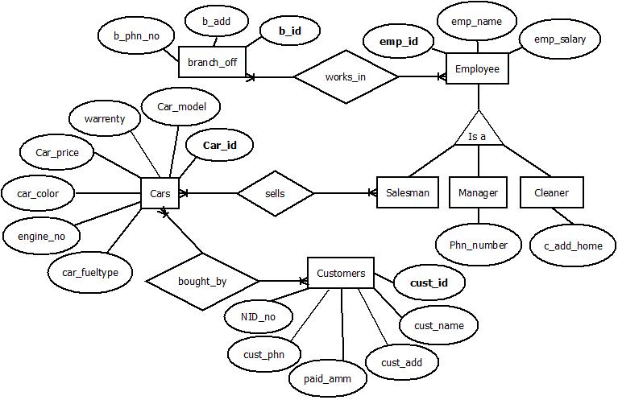

# **Bold** letters are denoted as **Primary Key**

**Normalization**

**Works­_in**

UNF: b_phn_no, b_add, **b_id, emp_id,** emp_name, emp_salary.

1NF:

Branch Office: **b_id,** b_phn_no, b_add.

Employee: **emp_id,** emp_name, emp_salary.

2NF:

Branch Office: b_phn_no, **b_id.**

Employee: **emp_id,** emp_name, emp_salary, b_id.

3NF:

Branch Office: **b_id,** b_phn_no.

Employee: **emp_id,** emp_name, emp_salary.

**Is s**

UNF: **emp_id,** emp_name, emp_salary, salesman, manager, cleaner.

1NF:

Employee: **emp_id,** emp_name, emp_salary.

Salesman: **emp_id**, salesman.

Manager: **emp_id**, manager, phn_number.

Cleaner: **emp_id**, cleaner, c_add_home.

2NF:

Is not needed for this. Because it is same as 1NF.

3NF:

Employee: **emp_id**, emp_name.

Salesman: emp_name.

Manager: emp_name, phn_number.

Cleaner: emp_name, c_add_home.

**Sells**

UNF: salesman, **Car_id**, car_model, warrenty, car_price, car_price, car_color, engine_no, car_fueltype.

1NF:

Salesman: **emp_id**, emp_name, salesman.

Cars: **car_id**, car model, warrenty, car_price, car_color, engine_no, car_ fueltype.

2NF:

Salesman: **emp_id**, emp_name.

Cars: **cars_id**, cars­_model, car_price, warrenty, car_color, engine_no, car_fueltype, emp_id.

3NF:

Salesman: emp_name.

Cars: **car_id**, car_model, warrenty, emp_id.

Cars1: car_model, car_price, car_color, engine_no, car_fueltype.

**Bought_by**

UNF: **car_id**, car_model, warrenty, car_price, car_price, car_color, engine_no, car_fueltype, **cust_id**, cust_name, cust_add, paid_amm, cust_phn, NID_no.

1NF:

Cars: **car_id**, car model, warrenty, car_price, car_color, engine_no, car_ fueltype.

Customers: **cust_id**, cust_name, cust_add, paid_amm, cust_phn, NID_no.

2NF:

Cars: **cars_id**, cars­_model, car_price, warrenty, car_color, engine_no, car_fueltype, emp_id.

Customers: **cust_id**, cust_name, cust_add, paid_amm, cust_phn, NID_no, cars_id.

3NF:

Cars: **car_id**, car_model, warrenty, emp_id.

Cars1: car_model, car_price, car_color, engine_no, car_fueltype.

Customers: cust_id, Nid_no, paid_amm, car_id.

Customers1: Nid_no, cust_name, cust_name, cust_phn.

**Screen Shots of Sample Data**

Branch_off Table:

SELECT * FROM branch_off;

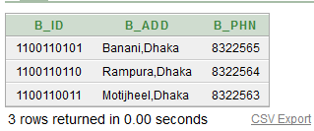

Employee Table:

SELECT * FROM employee1;

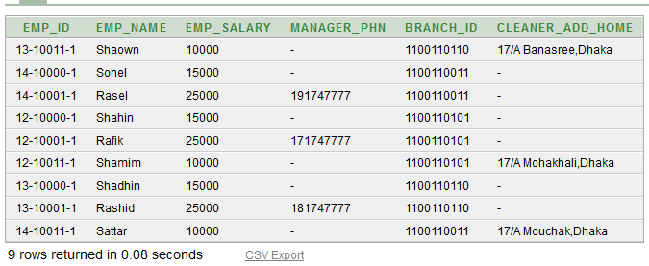

Cars Table:

SELECT * FROM cars;

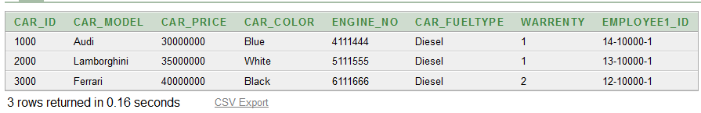

Customers Table:

SELECT * FROM customers;

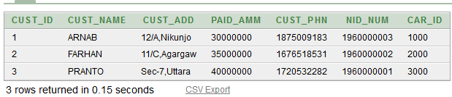

**SQL command for creating Table**

Branch Office

create table branch_off(

b_id number(10) primary key,

b_add varchar(200) not null,

b_phn number(12) not null

);

Employee

create table employee1

(

emp_id varchar(10) primary key,

emp_name varchar(100) not null,

emp_salary number(10) not null,

manager_phn number(10),

branch_id number(10),

cleaner_add_home varchar(100)

);

Cars

create table cars

(

car_id number(10) primary key,

car_model varchar(30) not null,

car_price number(10) not null,

car_color varchar(10) not null,

engine_no number(10) not null,

car_fueltype varchar(10) not null,

warrenty number(2),

employee1_id varchar(10) not null

);

Customers

create table customers

(

cust_id number(10) primary key,

cust_name varchar(100) not null,

cust_add varchar(100),

paid_amm number(10),

cust_phn number(15),

nid_num number(16) not null,

car_id number(10) not null

)

**SQL command for data entries**

**Branch info :**

insert into branch_off values (1100110101, 'Banani,Dhaka', 8322565);

insert into branch_off values (1100110110, 'Rampura,Dhaka', 8322564);

insert into branch_off values (1100110011, 'Motijheel,Dhaka', 8322563);

**Employee1 Info :**

insert into employee1 values ('12-10000-1', 'Shahin', '15000',null,1100110101,null);

insert into employee1 values ('12-10001-1','Rafik','25000',0171747777,1100110101,null);

insert into employee1 values ('12-10011-1', 'Shamim', '10000',null,1100110101,'17/A Mohakhali,Dhaka');

insert into employee1 values ('13-10000-1', 'Shadhin', '15000',null,1100110110,null);

insert into employee1 values ('13-10001-1','Rashid','25000',0181747777,1100110110,null);

insert into employee1 values ('13-10011-1', 'Shaown', '10000',null,1100110110,'17/A Banasree, Dhaka');

insert into employee1 values ('14-10000-1', 'Sohel', '15000',null,1100110011,null);

insert into employee1 values ('14-10001-1','Rasel','25000',0191747777,1100110011,null);

insert into employee1 values ('14-10011-1', 'Sattar', '10000',null,1100110011,'17/A Mouchak, Dhaka');

**Cars Info :**

insert into cars values (1000,'Audi', 30000000, 'Blue', 4111444, 'Diesel', 1, '14-10000-1')

insert into cars values (2000,'Lamborghini', 35000000, 'White', 5111555, 'Diesel', 1, '13-10000-1')

insert into cars values (3000,'Ferrari', 40000000, 'Black', 6111666, 'Diesel', 2, '12-10000-1')

**Customer Info :**

insert into customers values (1, 'ARNAB', '12/A,Nikunjo', 30000000, 01875009183, 1960000003, '1000')

insert into customers values (2, 'FARHAN', '11/C, Agargaw', 35000000, 01676518531, 1960000002, '2000')

insert into customers values (3, 'PRANTO', 'Sec-7,Uttara', 40000000, 01720532282, 1960000001, '3000')

**SQL command for creating view:**

create view Bills1

as(select b.b_add,b.b_phn,e.emp_name,c.car_model,c.car_color,c.car_fueltype,c.warrenty,c.car_price,cs.cust_name,cs.cust_add,cs.nid_num

from branch_off b,employee1 e,cars c, customers cs

where b.b_id=e.branch_id and e.emp_id=c.employee1_id and c.car_id=cs.c_id);

select *

from Bills1;

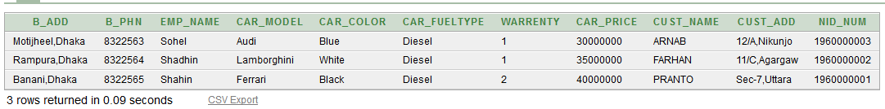

**Sample Questions :**

1.Show all the customers informations.

Ans: select *

from customers;

2.Show all the employee name from Branch number 1100110011.

Ans: select emp_name

from employee1

Where branch_id=1100110011;

3. Show the employee name & branch number for all employees whose name contains the letter s.

Ans: select e.emp_name,e.branch_id

from employee1 e

join employee1 n

on e.branch_id=n.branch_id

and n.emp_name like '%s%' ;

4. Show the employee name, salary and branch number for all employees who work in the branch as employee number 13-10001-1.

Ans: select emp_name,emp_salary,branch_id

from employee1

where branch_id=(select branch_id

from employee1

where emp_id='13-10001-1')

5. Display the car number, model and price for the customer whose name is PRANTO.

Ans: select car_id, car_model, car_price

from cars

where car_id=(select car_id

from customers

where cust_name='PRANTO');

**Conclusion:**

The purpose of this car dealer company database management system is to store all the information about the company’s car and the information of the employer of this company.

**PART B**

**Learning Experience**:

This project has been a rewarding experience in more than one way. The entire project work has enlightened us in the following areas.

* Digital car dealership solutions for Sales and Service .
* Customer information available on every terminal device, securely from the Cloud.
* Data synchronization with the Dealer-Management-System.
* Efficient processes for a digital customer experience.

**Problems Faced :**

* Increasing Competitive Pressures.
* Service Pressures.
* Finding more qualified leads.
* Competing with a lower-priced competitor whose promises won't hold up over time.

Despite our best effort there might be some faults in our developed database. We hope to learn from our mistakes and apply the knowledge that we gained from this project in the future to craete more professional level database.